Wow! October is here already!. We are settling nicely into preschool, and have a fun filled month.

October Themes
Oct. 4 & 6-- Thanksgiving
Talking about what we are thankful for and making a special Turkey friend.
Oct. 11 & 13-- Pets
What kind of pet do you have or would like to have? We will be chatting about all the different pets people might have and bringing home our own special pet we have made at school.
Oct. 18, 20, 25 & 27---- Halloween!
We will be busy decorating and getting ready for our Halloween Hoot. We will also talk about the colour orange.
Oct. 20th—Picture day--- Forms will be sent home, you must return forms with payment to have your child’s photo taken.
Oct. 25th please dress in orange and bring an orange coloured snack. (Each month we will be having a different day assigned for a colour).
Oct. 27th --- Halloween Hoot---- Children will come to school dressed in their costume. We will have special center’s planned for this day. There will be a sign up genius sent out for snack sign ups.

Important Dates
October 20th - Picture Day
October 25st – Orange Day
October 27th – Halloween Hoot

Important Reminders
*Lunch bags in child’s small cubby and leave backpacks unzipped on hook and outside shoes in bottom cubby.
*Small healthy snacks (please cut grapes in half and no cookies or gummies).
* Check your child’s mailbox under their name.
* Please sign up for your duty days, on the 20th of each month.
* Volunteers needed for cleaning night and casino. Please sign up on the sign up genius when its sent out.
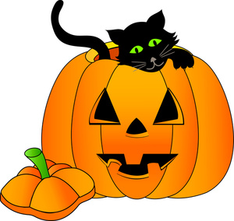
If you have any questions or concerns please feel free to talk to us after class.

